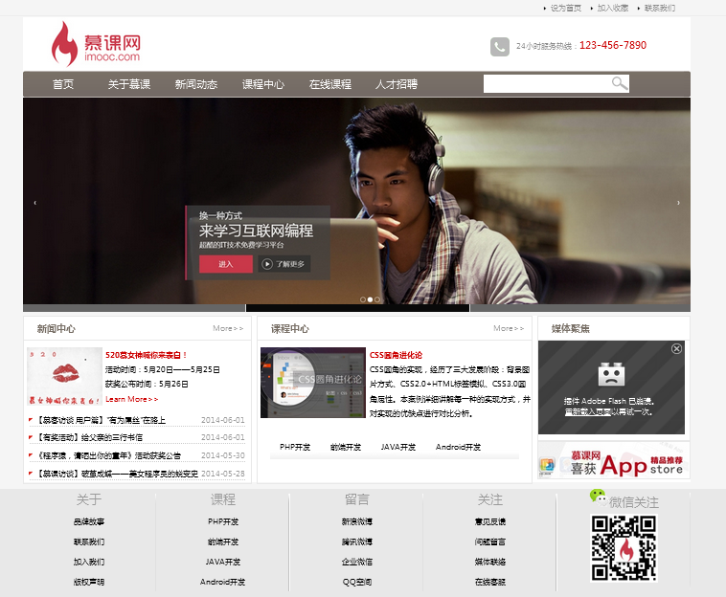

<!DOCTYPE html PUBLIC "-//W3C//DTD XHTML 1.0 Transitional//EN" "http://www.w3.org/TR/xhtml1/DTD/xhtml1-transitional.dtd">

<html xmlns="http://www.w3.org/1999/xhtml">

<head>

<meta http-equiv="Content-Type" content="text/html; charset=utf-8" />

<title>无标题文档</title>

<link href="css/main.css" rel="stylesheet" type="text/css" />

<script src="js/setHomeSetFav.js" type="text/javascript" charset="gb2312"></script>

<script src="js/myfocus-2.0.1.min.js" type="text/javascript"></script>

<script src="js/mf-pattern/mF_fancy.js" type="text/javascript"></script>

<link href="js/mf-pattern/mF_fancy.css" rel="stylesheet" type="text/css" />

<script type="text/javascript">

myFocus.set({

id:'picBox'})

</script>

</head>

<body>

<div class="top">

<div class="top_content">

<ul>

<li><a href="#">联系我们</a></li>

<li><a href="#" onclick="AddFavorite(window.location,document.title)">加入收藏</a></li>

<li><a href="#" onclick="SetHome(window.location)">设为首页</a></li>

</ul>

</div>

</div><!--top结束-->

<div class="wrap">

<div class="logo">

<div class="logo_left">

<img src="images/logo.jpg" alt="慕课网"/>

</div>

<div class="logo_right">

<img src="images/tel.jpg" alt="服务热线" />24小时服务热线：<span class="tel">123-456-7890</span>

</div>

</div><!--logo结束-->

<div class="nav">

<div class="nav_left"></div>

<div class="nav_mid">

<div class="nav_mid_left">

<ul>

<li><a href="#">首页</a></li>

<li><a href="list.html">关于慕课</a></li>

<li><a href="list.html">新闻动态</a></li>

<li><a href="list.html">课程中心</a></li>

<li><a href="list.html">在线课程</a></li>

<li><a href="list.html">人才招聘</a></li>

</ul>

</div>

<div class="nav_mid_right">

<form action="" method="post">

<input type="text" class="search_text"/>

</form>

</div>

</div>

<div class="nav_right"></div>

</div><!--nav导航结束 -->

<div id="picBox" class="ad">

<div class="loading"><img src="images/loading.gif" alt="图片加载中" /></div>

<div class="pic">

<ul>

<li><img src="images/ad2.jpg" /></li>

<li><img src="images/ad3.jpg" /></li>

<li><img src="images/ad4.jpg" /></li>

</ul>

</div>

</div><!--ad结束 -->

<div class="main">

<div class="news">

<div class="title">

<h2 class="title_left">新闻中心</h2><span class="title_right"><a href="news.html">More&gt;&gt;</a></span>

</div><!--title结束 -->

<div class="pic_news">

<img src="images/news.jpg" /><h2><a href="#">520慕女神喊你来表白！</a></h2><p>活动时间：5月20日——5月25日<br />获奖公布时间：5月26日<br /><a href="#">Learn More&gt;&gt;</a></p>

</div><!--pic_news结束 -->

<div class="news_list">

<ul>

<li><span class="date">2014-06-01</span><a href="news.html">【慕客访谈 用户篇】"有为屌丝"在路上</a></li>

<li><span class="date">2014-06-01</span><a href="news.html">【有奖活动】给父亲的三行书信</a></li>

<li><span class="date">2014-05-30</span><a href="news.html">《程序猿，请晒出你的童年》活动获奖公告</a></li>

<li><span class="date">2014-05-28</span><a href="news.html" title="aa">【慕课访谈】破茧成蝶——美女程序员的蜕变史</a></li>

</ul>

</div><!--news_list结束 -->

</div><!--news结束 -->

<div class="course">

<div class="title">

<h2 class="title_left">课程中心</h2><span class="title_right"><a href="#">More&gt;&gt;</a></span>

</div><!--title结束-->

<div class="course_pic">

<img src="images/css.jpg" /><h2><a href="#">CSS圆角进化论</a></h2>

<p>CSS圆角的实现，经历了三大发展阶段：背景图片方式、CSS2.0+HTML标签模拟、CSS3.0圆角属性。本案例详细讲解每一种的实现方式，并对实现的优缺点进行对比分析。</p>

</div><!--course_pic结束-->

<div class="course_type">

<ul>

<li>PHP开发</li>

<li>前端开发</li>

<li>JAVA开发</li>

<li>Android开发</li>

</ul>

</div><!--course_type结束-->

</div><!--course结束 -->

<div class="sidebar">

<div class="video">

<div class="title">

<h2 class="title_left">媒体聚焦</h2>

</div>

<div class="video_content">

<embed src="http://player.ku6.com/refer/V3L_RUSqNX7LGayUACVhaQ../v.swf" width="220" height="140" allowscriptaccess="always" allowfullscreen="true" type="application/x-shockwave-flash" flashvars="from=ku6"></embed>

</div>

</div><!--video结束-->

<div class="sidebar_ad">

<img src="images/app.jpg" />

</div><!--sidebar_ad结束-->

</div><!--sidebar结束 -->

</div><!--main结束 -->

</div><!--wrap结束-->

<div class="copyright">

<div class="copyright_content">

<ul>

<li><a href="#">关于</a>

<ul>

<li>品牌故事</li>

<li>联系我们</li>

<li>加入我们</li>

<li>版权声明</li>

</ul>

</li>

<li><a href="#">课程</a>

<ul>

<li>PHP开发</li>

<li>前端开发</li>

<li>JAVA开发</li>

<li>Android开发</li>

</ul>

</li>

<li><a href="#">留言</a>

<ul>

<li>新浪微博</li>

<li>腾讯微博</li>

<li>企业微信</li>

<li>QQ空间</li>

</ul>

</li>

<li><a href="#">关注</a>

<ul>

<li>意见反馈</li>

<li>问题留言</li>

<li>媒体联络</li>

<li>在线客服</li>

</ul>

</li>

<li><a href="#"><img src="images/weixin.png" />微信关注</a>

<ul>

<li><img src="images/qrcode.jpg" /></li>

</ul>

</li>

</ul>

</div>

</div><!--copyright结束 -->

</body>

</html>

*{ margin:0; padding:0; font-size:12px;}

body{ background:#F5F5F5;}

.top{ width:100%; background:url(../images/top_bg.jpg) repeat-x; height:27px;}

.top_content{ width:1000px; margin:0 auto;}

.top_content li{ list-style-image:url(../images/li_bg.gif); float:right; width:70px; line-height:27px;}

.top_content a:link,.top_content a:visited{ color:#8e8e8e; text-decoration:none;}

.top_content a:hover,.top_content a:active{ color:#F00; text-decoration:none;}

.wrap{ width:1000px; margin:0 auto;}

.logo{ height:80px; background:#FFF;}

.logo_left{ width:200px; float:left;}

.logo_right{ width:300px; float:right; height:28px; margin-top:30px; color:#8e8e8e;}

.logo_right img{ vertical-align:middle; margin-right:10px;}

.tel{ font-family:"微软雅黑"; font-size:16px; color:#c00;}

.nav{ height:40px;}

.nav_left{ width:10px; background:url(../images/nav_left.jpg) no-repeat;}

.nav_mid{ width:980px; background:url(../images/nav_bg.jpg) repeat-x;}

.nav_right{ width:10px; background:url(../images/nav_right.jpg) no-repeat;}

.nav_left,.nav_mid,.nav_right{float:left; height:40px;}

.nav_mid_left,.nav_mid_right{ float:left;}

.nav_mid_left{ width:680px;}

.nav_mid_right{ width:300px;}

.nav_mid_left li{ float:left; list-style:none; line-height:40px; width:100px; text-align:center;}

.nav_mid_left a:link,.nav_mid_left a:visited{ text-decoration:none; color:#fff; font-size:16px; font-family:"微软雅黑";}

.nav_mid_left a:hover,.nav_mid_left a:active{ text-decoration:none; color:#ff0; font-size:16px; font-family:"微软雅黑";}

.search_text{ width:190px; height:25px; margin-top:6px; background:url(../images/search.jpg) no-repeat right center; background-color:#fff; padding-right:25px;border:1px solid #fff;}

.ad{ height:310px; overflow:hidden;}

.main{ height:250px; background:#fff; margin-top:5px;}

.news{ width:340px; border:1px solid #e8e8e8;}

.course{ width:410px; border:1px solid #e8e8e8; margin:0 7px;}

.sidebar{ width:230px;}

.news,.course,.sidebar{ height:250px; float:left;}

.title{ height:35px; border-bottom:2px solid #e8e8e8;}

.title_left{ width:70%; font-family:"微软雅黑"; font-size:14px; font-weight:bold; color:#786f66; float:left; line-height:35px; padding-left:20px;}

.title_right{ width:20%; float:right; line-height:35px; text-align:right; padding-right:10px;}

.title_right a{ text-decoration:none; color:#999999;}

.pic_news{ height:80px; margin-top:10px; line-height:22px;}

.pic_news img,.course_pic img{ float:left; margin:0 5px;}

.pic_news a,.course_pic a{ color:#C00; text-decoration:none;}

.news_list{ margin-top:20px;}

.news_list li{ list-style-type:none; background:url(../images/list.jpg) no-repeat; padding-left:10px; margin:8px; border-bottom:1px dotted #ccc;}

.news_list a:link,.news_list a:visited{ text-decoration:none; color:#000;}

.news_list a:hover,.news_list a:active{ text-decoration:none; color:#f00;}

.date{ color:#999; float:right;}

.course_pic{ height:120px; margin-top:10px; line-height:22px;}

.course_type{ height:37px; width:372px; background:url(../images/product_type_bg.jpg) no-repeat;margin:20px auto;}

.course_type li{ list-style-type:none; float:left; line_height:37px; margin:0 15px;}

.video{ height:185px; border:1px solid #e8e8e8;}

.video_content{ height:150px;}

.sidebar_ad{ height:55px; border:1px solid #e8e8e8; margin_top:10px;}

.copyright{ width:100%; height:200px; background:#e8e8e8; margin-top:10px;}

.copyright_content{ width:1000px; margin:0 auto; margin-top:10px;}

.copyright_content li{ float:left; list-style:none; width:200px; background:url(../images/line.png) no-repeat right center; text-align:center; line-height:30px; font-family:"微软雅黑";}

.copyright_content a{ text-decoration:none; color:#999; font-size:18px;}